St John the Baptist church
Castle Hill Road Birtle, Bury BL9 6UH
Come & joins us for
Afternoon Tea
Games,Quiz, children’s activity
To celebrate

The Queen's Platinum Jubilee 2022

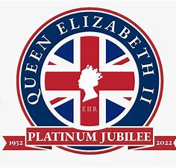
Sunday 5th June 2.00pm
Back to 1953
All welcome

